**BUCKEYE RUG HOOKING GUILD - SUMMER HOOK-IN**

**JOHNSTOWN LIBRARY**

(320 n. Main St., Johnstown, Oh)

**Saturday, June 21, 2025**

(10:30 am – 2:30 pm)

**Fun Activities**

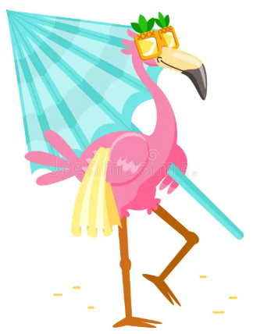 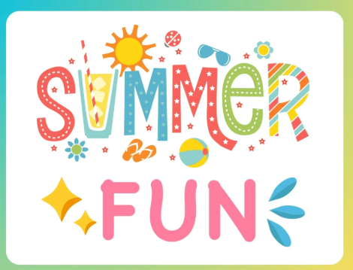 

**Guest Speaker - Lois Lahman:** “Embellishing Your Rugs” – she will be bringing many examples to share and inspire you!

**Gale Weideman:** Vending includes- her original paper patterns of animals, birds, floral

& geometrics, also beautiful note cards and journals (cash & carry only).

**Pamelyn Thacker Studio:** Vending includes- Gale Weideman’s patterns on linen backing along with a table full of other wonderful rug hooking goodies.

**Lunch:** Please bring your own lunch, drinks and dessert will be provided

**Deadline for registration:** June 14th, 2025

**Please mail your registration to:**

Kay Thode

11301 Vans Valley Road

Galena, Oh 43021

*\*\* This is a* ***Members Only Event*** *and space is limited, so don’t wait to register! \*\**

**BRHG Summer Hookin**

**Name**:___________________________________ **Today’s Date**:__________________________

**Address**:__________________________________________________________________________

**Email**:_______________________________________ **Ph#**________________________________

**Emergency Contact**:______________________________ **Ph#**____________________________