**BRHG FALL HOOK IN – SPRING 2026**

**KELLY KANYOK – APRIL 9TH – 10TH 2026 (THURS. & FRIDAY)**

**“ COMBINATION PUNCH NEEDLE & RUG HOOKING CLASS” – PROJECT SELECTION FORM**

NAME:______________________________________________PHONE:_____________________________________________

EMAIL:___________________________________________________________________________________________________

The following lists the options available for the patterns & wool. No money is due at this time as we will settle bills on the last day of the workshop with CASH or CHECK payment. Please review the options carefully, and return these forms back to: **Ronda Elavsky/Education Chair email:** [**Ronda.Elavsky@nrg.com**](mailto:Ronda.Elavsky@nrg.com) **or 1005 Jimson Ct. Galloway, OH 43119**

**Select your favorite option below. Your materials (pattern and/or wool) will be provided to you on the first day of class.

***Patterns/Kits below: Paid directly to Kelly Kanyok at the time of class***

* **#1 Golden Glow**-   
  Combination Art Kit **$75.00 (w/o wool)**CompletePattern Size: 16x16 (Punch needle size 5x5)

Includes Rug Hooking Pattern/Mini Needle Punch Pattern & Floss

* **#2 Lovely Lilac**-   
  Combination Art Kit **$75.00 (w/o wool)**Complete Pattern Size: 16x16 (Punch needle size 5x5)

Includes Rug Hooking Pattern/Mini Needle Punch Pattern & Floss

* **#3 Sweet Pink-**Combination Art Kit **$69.00 (w/o wool)**Complete Pattern Size: 14 x 14 (Punch needle size 5x5)

Includes Rug Hooking Pattern/Mini Needle Punch Pattern & Floss

* **#4 Truly Teal**-   
  Combination Art Kit **$69.00 (w/o wool)**CompletePattern Size: 14x14 (Punch needle size 5x5)

Includes Rug Hooking Pattern/Mini Needle Punch Pattern & Floss

* **Ultra Punch Needle Purchase $ 26.00**

***Wool Only below: Paid directly to Pamelyn Thacker at the time of class***

* **#1 Golden Glow** **Wool $ 140.00**

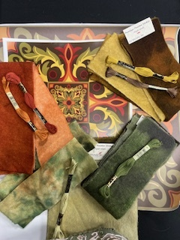

* **#2 Lovely Lilac Wool $140.00**



* **#3 Sweet Pink Wool $ 120.00**

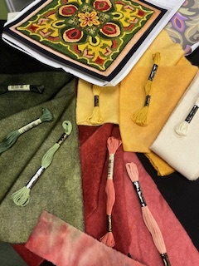

* **Truly Teal Wool $ 120.00**

